Test Plan
Group: Cloud

Group Members:
Andrew XU(Leader)
James LUO(Secretary)
Charles ZHOU

TABLE OF CONTENTS

1. Module to test 3
1.1. User login 3
1.2 Table Allocating 3
2.Test mothods 3
2.1 Ssytem test 3
2.2 User experience optimizing 3
3. Test Cases 5
3.1 Test cases & expected output 5

Test Plan

1.Module to test
Prepared by : James .LUO

- 1User login
1.2.Table Allocating
a).New customer not allowed together
b).New customer allowed together
c).Waiting list
d).Booking

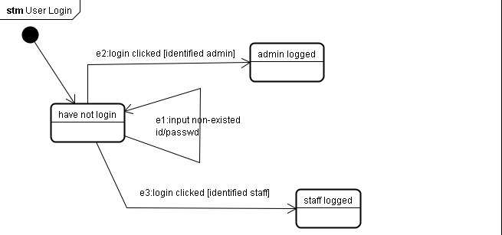
2.Test Methods
2.1System test:
2.1.1.User login
Module num:1
Path:
- e1
- e2
- e3

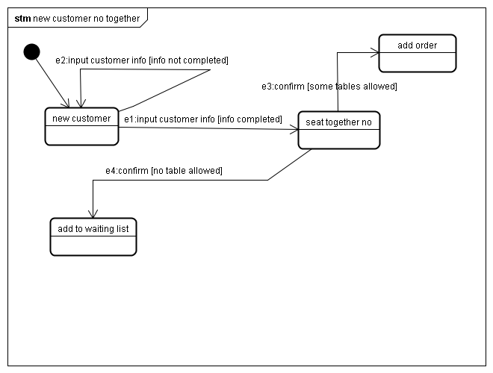
2.1.2a.New customer not allowed together
Module num:2a
Path:
- e2
- e1->e3
3.e1->e4

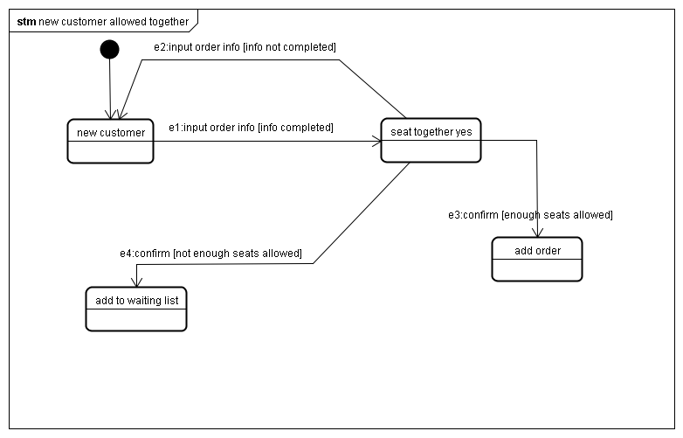
2.1.22b.New customer allowed together
Module num:2b
Path:
- e2
2.e1->e3
3.e1->e4

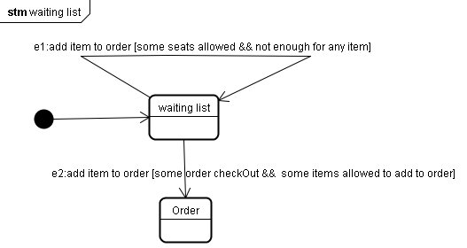
2.1.2c.Waiting list
Module num:2c
Path:
1.e1
2.e2

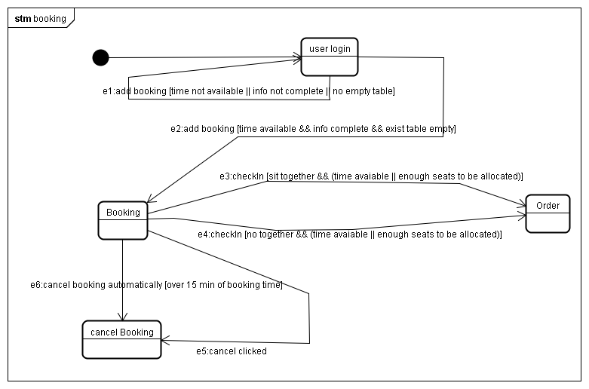
2.1.22d.Booking
Module num:2d
Path:
1.e1
2.e2->e3
3.e2->e4
4.e2->e5
5.e2->e6

3.Test cases
3.1Test cases & expected output:
Num of path(module num+'.'+path num)
Num of test path | Num of test cases | Test data | Expected Output | Bug
1->1 | 1 | Username:James  Passwd:James | Not allowed to login
1->2 | 2 | Username:Admin  Passwd:Admin | Admin logged in
1->3 | 3 | Username:Staff  Passwd:Staff | Staff logged in
2a->1 | 4 | Guest Amount:0 | Input error
 | 5 | Guest Amount:-1 | Input error
 | 6 | Guest Amount:aa | Input error
 | 7 | Guest Amount:~ | Input error
2a->2 | 8 | Guest Amount:8(<Standard Capacity)  Some empty table allowed | Occupied to the table
2a->3 | 9 | Guest Amount:12(> Standard Capacity)  Some empty table allowed | Add to waiting list
2b->1 | 10 | Guest Amount:0 | Input error
 | 11 | Guest Amount:-1 | Input error
 | 12 | Guest Amount:aa | Input error
 | 13 | Guest Amount:~ | Input error
2b->2 | 14 | Guest Amount: 8 | Occupied to the tables
 | 15 | Guest Amount: 12 | Occupied to the tables
2b->3 | 16 | Guest Amount: 8 | Add to wating list
 | 17 | Guest Amount: 12 | Add to waiting lsit
2c->1 | 18 | Guest num in waiting list: 20 | remain
2c->2 | 19 | Guest num in waiting list: 20 | Occupying tables
2d->1 | 20 | Guest Amount:0 | Input error
 | 21 | Guest Amount:-1 | Input error
 | 22 | Guest Amount:aa | Input error
 | 23 | Guest Amount:~ | Input error
 | 24 | Booking time is now | Not allowed
 | 25 | Booking time before now | Not allowed
 | 26 | Guest num:20 | No seat allowed
 | 27 | Guest num:10  No empty table | No seat allowed
2d->2 | 28 | Guest num:10  Time suitable  info completed  empty table exist  seat together | Seat allowed
 | 29 | Guest num:10  Time suitable  info completed  empty table exist  seat together | Not allowed
 | 30 | Guest num:10  Time suitable(within 2 hours till now)  info completed  empty table exist  seat together | Allowed | Cancel automatically and no new orders
2d->3 | 31 | Guest num:10  Time suitable  info completed  empty table exist  no seat together | Allowed
 | 32 | Guest num:10  Time suitable  info completed  empty table exist  no seat together | Not allowed
 | 33 | Guest num:10  Time suitable(with in 2hours till now)  info completed  empty table exist  no seat together | Allowed | Cancel automatically and no new orders
2d->4 | 34 | 15min over booking time | Cancel automatically
2d->5 | 35 | Cancel clicked | Cancel book manually

